

**GROUP ASSIGNMENT**

**21.1**

**National School of Business Management**

**SE303.3– Mobile Application Development MAD**

|  |  |  |
| --- | --- | --- |
| **Index** | **Name** | **Degree** |
| 22851 | H.H Senavirathna | SE |
| 22863 | W.D Fernando | SE |
| 23863 | M.M.I.R.Chandrasiri | SE |
| 22809 | D.R.I.Alahakoon | CS |
| 22884 | K.A.U.U.D.S.Jayasekara | SE |
| 22803 | H.M.Y.A Afri | CS |

**Coursework Type:** Take Home Group Assignment

**Module Leader:** **Mr. Dilan Perera.**

Table of Content

* Project Overview……………..………………………………….0
* Problem Identification……………………………………..….0
* Proposed Solutions………………………………………………0
* Benefits for NSBM……………………………………………….0
* Stakeholders……..…………………………………………………0
* Diagrams……………………………………………………………..0
* Screenshots…………………………………………………………0
* Technologies Used………………………………………….…..0
* Integrations with Other Systems………………………….0
* High-level Architecture………………………………………..0
* Responsibilities of Each Team Member………………..0
* Project Plan and Execution…………………………………..0

1. **Project Overview**

* The goal of the NSBM System Enhancement Project is to overcome significant obstacles that the academic community faces when trying to access library information and resources quickly. The current system has issues with resource availability, administrative processes, and information retrieval. To address these issues, we suggest creating an effective mobile application specifically for the library at NSBM. It will be made to offer students and instructors a seamless and user-friendly interface, boosting their overall library experience.

1. **Problem Identification:**

* Inefficient Information Access: Faculty and students have trouble accessing library information and resources efficiently. They have trouble finding books, determining their availability, or locating relevant resources for their courses.
* Administrative procedures that are time-consuming and prone to error include the borrowing, returning, and tracking of books. Both users and library employees find it time-consuming and frustrating.
* Students often struggle to find available halls, check their capacity, and navigate the reservation system.

1. **Proposed Solutions**

* To address these challenges, we are proposing to develop a mobile app for NSBM's library system for students. The app will provide a convenient and user-friendly interface for students and faculty to interact with the library's resources and services efficiently.
* Through this mobile application enhanced accessibility, improved user experience, real-time updates and notifications, personalization, improved administrative efficiency, and multi-platform accessibility can be achieved making it the ideal solution for addressing the challenges in NSBM's library system.
* **Enhanced Accessibility:** Using a mobile app, lecturers, staff, and students can access library materials whenever and wherever they want, without having to go in person or use a desktop computer.
* **Improved User Experience:** The app offers a simple and user-friendly interface created especially for mobile devices, making it simple to discover information and perform tasks.
* **Real-time Updates and Notifications:** Users receive push notifications that provide real-time updates on book availability, due dates, and notifications, helping them stay informed and effectively manage their library-related tasks.
* **Personalization:** To improve the user experience, the app shows borrowed books, due dates, and recommendations based on user interests.
* **Enhanced Administrative Efficiency:** Automating administrative procedures through integration with the library's database cuts down on mistakes and errors and concentrates on offering individualized help.
* **Accessibility across several platforms**: The mobile app supports both iOS and Android, providing to a wide range of users and ensuring that all academics, staff, and students have equal access to library resources.

1. **Benefits for NSBM**

**Improved Operational Efficiency:**

* The mobile app simplifies administrative processes for tracking, returning, and borrowing books. By reducing the time and effort needed by both users and library personnel, automation of these operations improves overall operational effectiveness.

**Enhanced user experience:**

* The app's elegant and user-friendly UI significantly improves the library experience for both students and instructors. An improved user experience is facilitated by quick access to information, individualized recommendations, and simple study room reservations.

**Real-time updates and notifications:**

* Users are kept updated with real-time updates on book availability, due dates, and notifications on reservations and overdue books. This feature makes it possible to plan and handle library-related work effectively, which helps to create a user base that is more structured and knowledgeable.

**Cost Savings:**

* The mobile app helps to reduce costs associated with manual processes by automating procedures and cutting errors. Additionally, longer-term cost savings may result from increased resource management efficiency.

**Improved resource utilization:**

* The 'Favorites' function of the program enables users to bookmark and quickly access their favorite books, articles, or resources. This helps the library use its resources effectively, ensuring that users can promptly obtain the materials they need.

**Better engagement and communication:**

* Through push notifications, the mobile app enables direct and immediate engagement with consumers. As a result, users are more likely to engage with library resources and services, improving the flow of information between the library and the users.

**Data-driven decision-making:**

* Effective data gathering and analysis are made possible through integration with the library's database. To improve the library's services and products, decision-makers can use the information gathered from user interactions in the app.

**Global accessibility:**

* A wide range of users, including students, teachers, and staff, can access the library's materials and services from anywhere in the world thanks to the app's compatibility with both iOS and Android platforms.

**Enhanced productivity:**

* The mobile app enables instructors and students to spend more time on academic pursuits by offering a streamlined and effective way to access resources and manage reservations. This increases their productivity and their focus on their studies**.**

**Adoption of modern technology:**

* The mobile app demonstrates NSBM's dedication to delivering cutting-edge solutions and upgrading services to satisfy the changing requirements and expectations of its academic community and places the organization in step with the technological trends.

1. **Stakeholders:**

**Students:**

* The main stakeholder who would be impacted by the mobile app is students. They will gain easier access to library materials, a streamlined borrowing procedure improved reservations for study spaces, and recommendations that are tailored to their interests.

**Faculty:**

* Significant stakeholders who will profit from easy access to academic resources for research and teaching materials include faculty members. The app will make it easier to identify relevant materials and will improve communication with the library system.

**Library Staff and Administrators:**

* The proper management of library resources and services is the responsibility of the administration and personnel. They will be better able to track and manage borrowing, reservations for study spaces, and notifications thanks to the app. It will streamline the procedures, increasing production in the end.

**NSBM management:**

* An important stakeholder with an interest in the overall effectiveness and efficiency of the library management system is the management of NSBM. The mobile app supports the organization's objectives of giving the academic community an effective service while increasing the institution's reputation.

**IT department:**

* The IT department of NSBM is a crucial player in guaranteeing the app's flawless integration with current systems, its privacy, and its compatibility across multiple devices and platforms.

**Vendors and Developers:**

* Stakeholders with a vested interest in the success and acceptance of the mobile app include vendors or third-party developers involved in its creation and maintenance. Their cooperation is necessary for the app's operation and its development.

1. **Diagrams**

**Usecase Diagram**

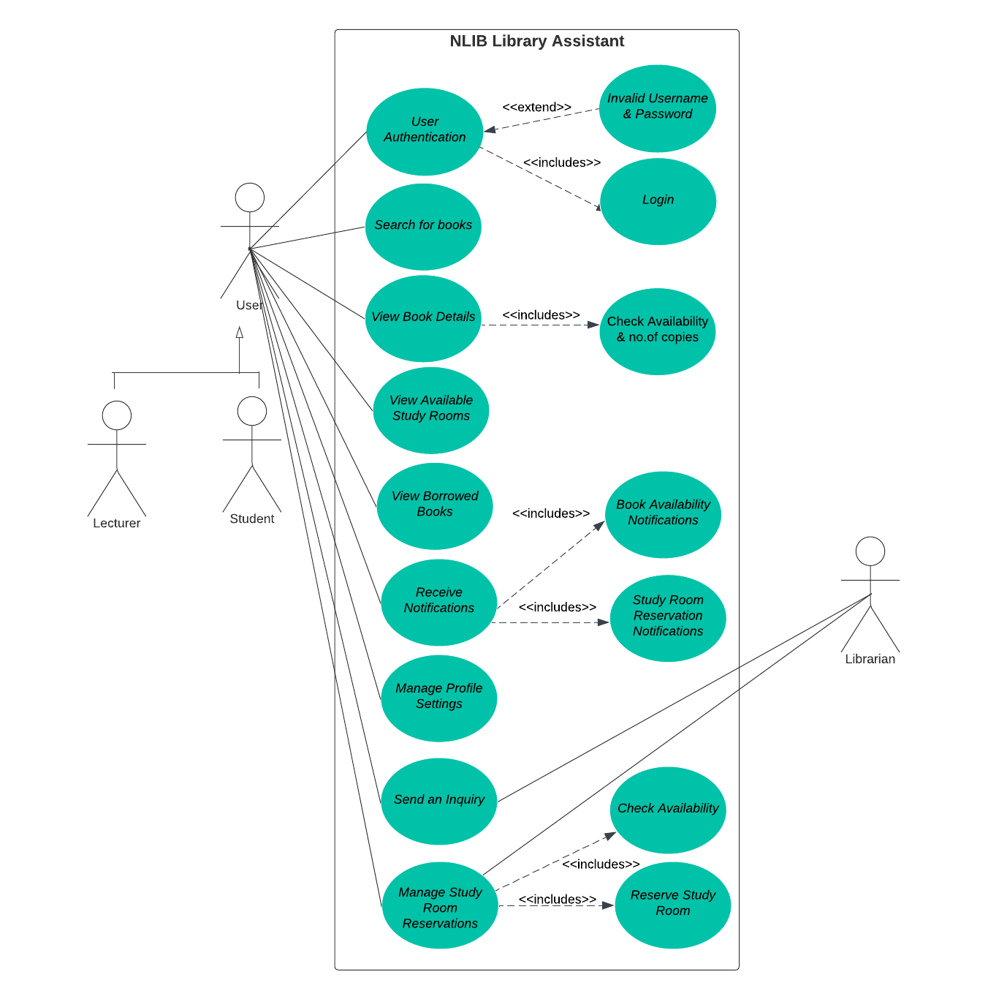

**Activity Diagram**

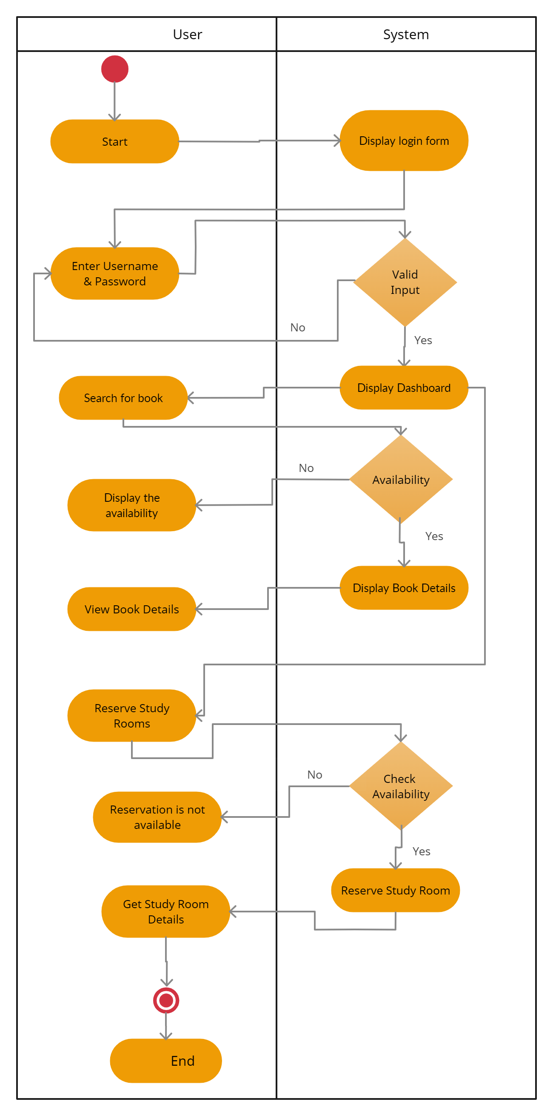

1. **Screenshots**



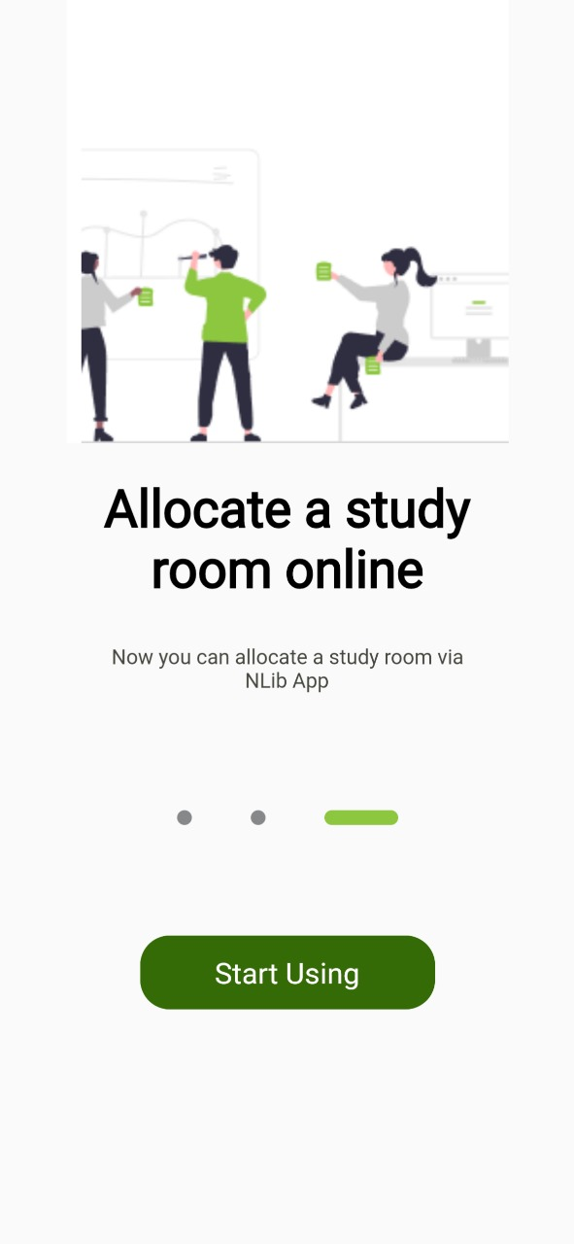

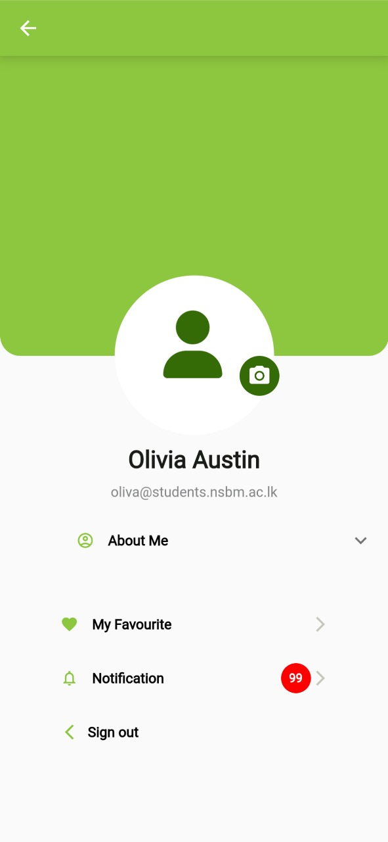

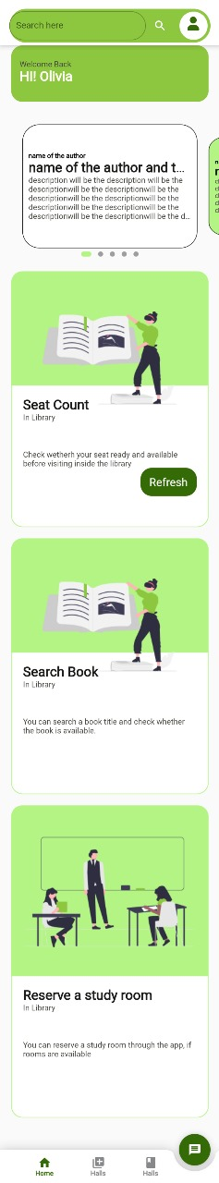

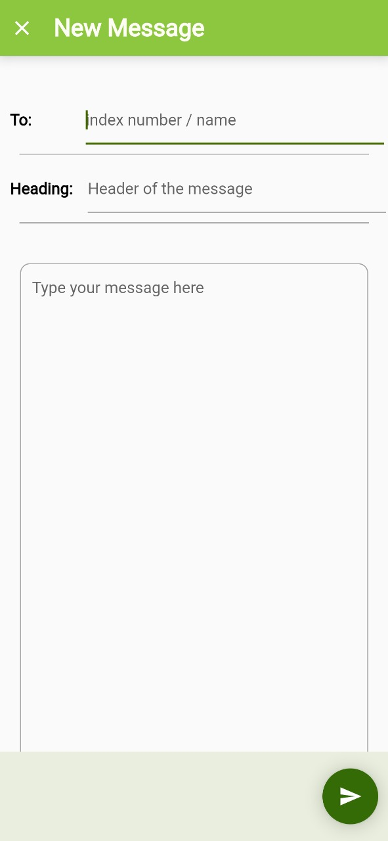

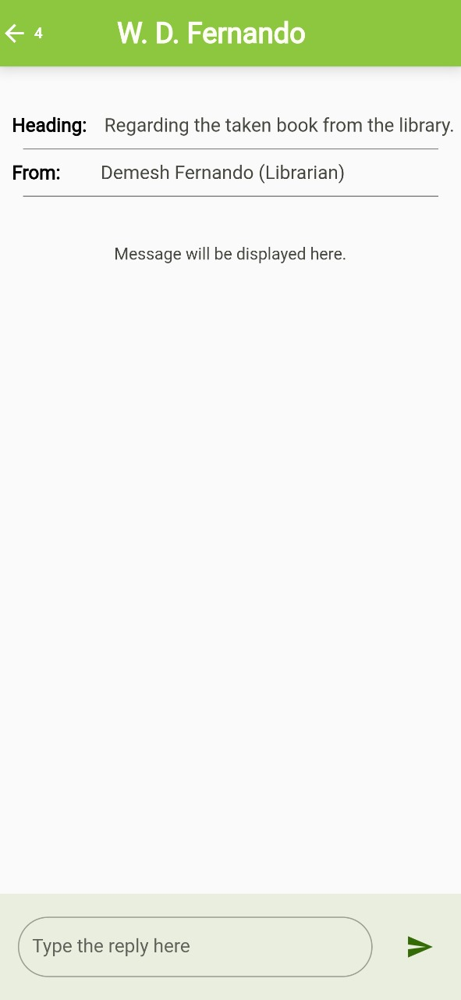

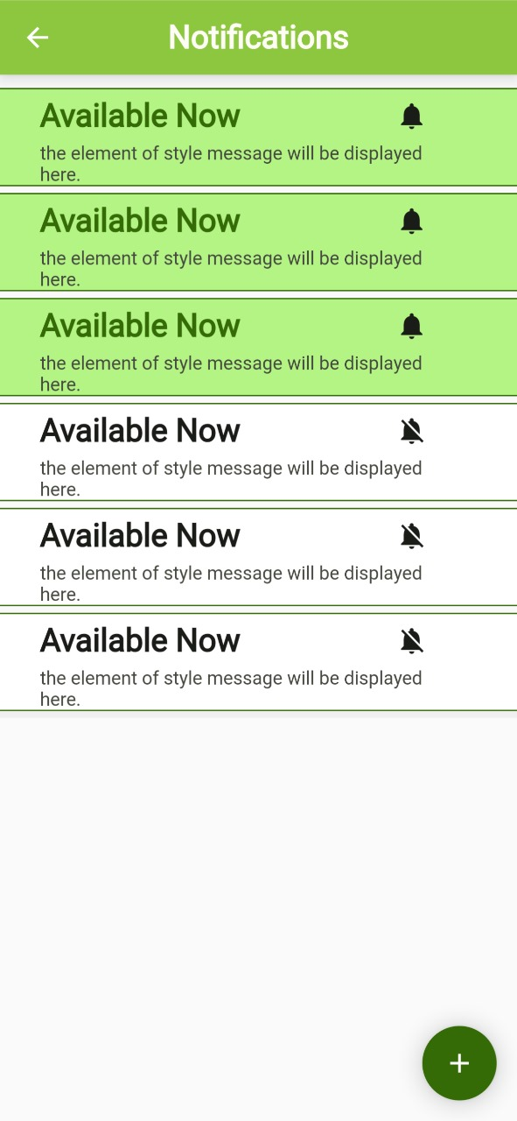

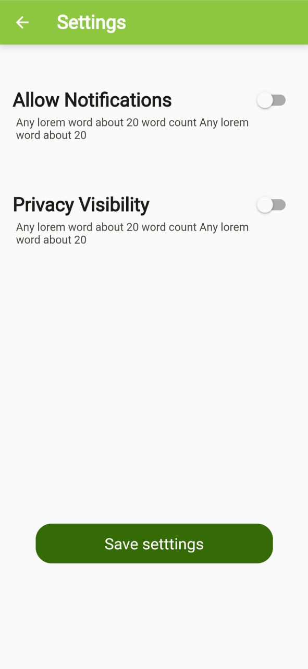



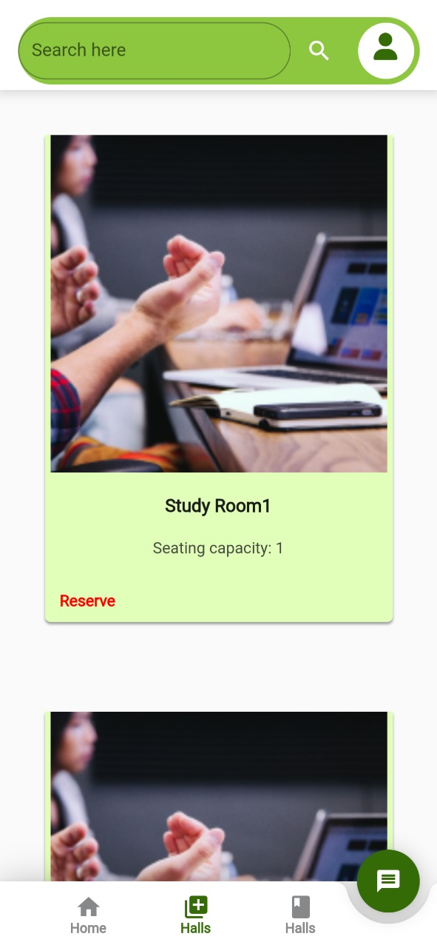

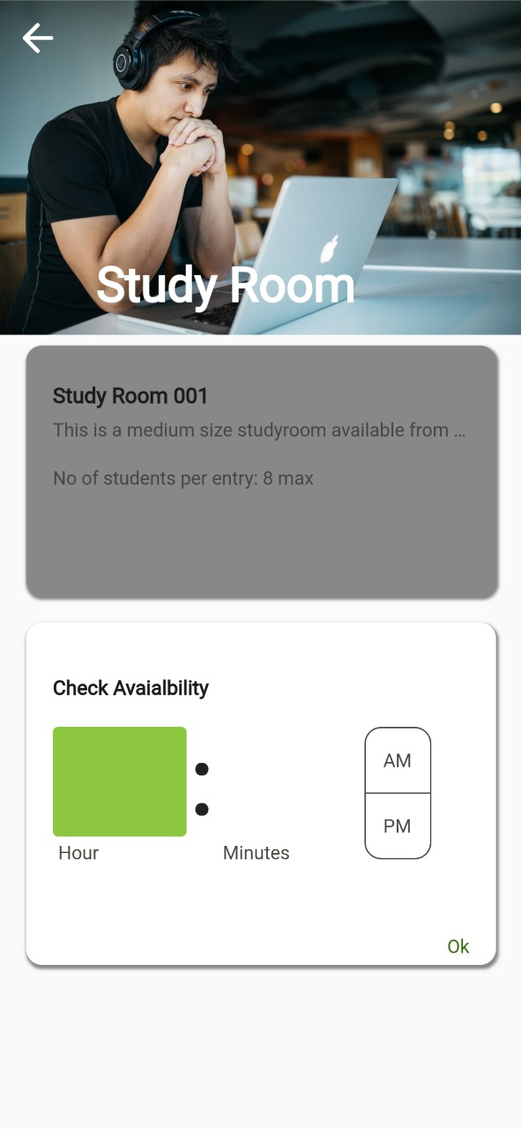

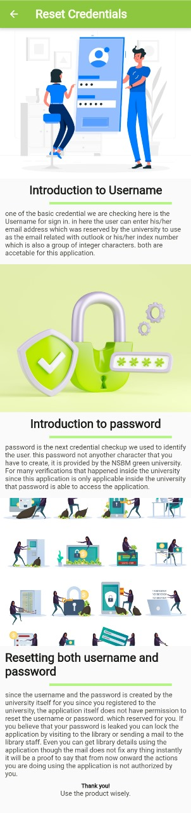

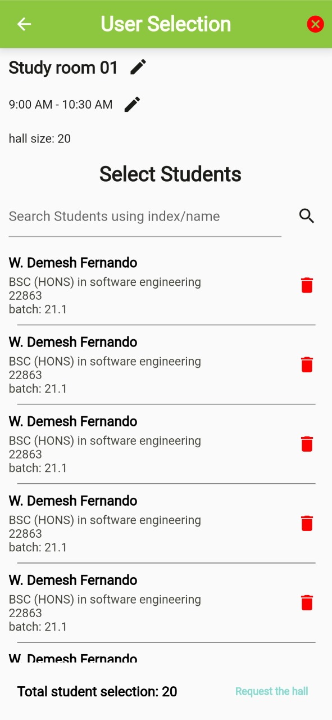

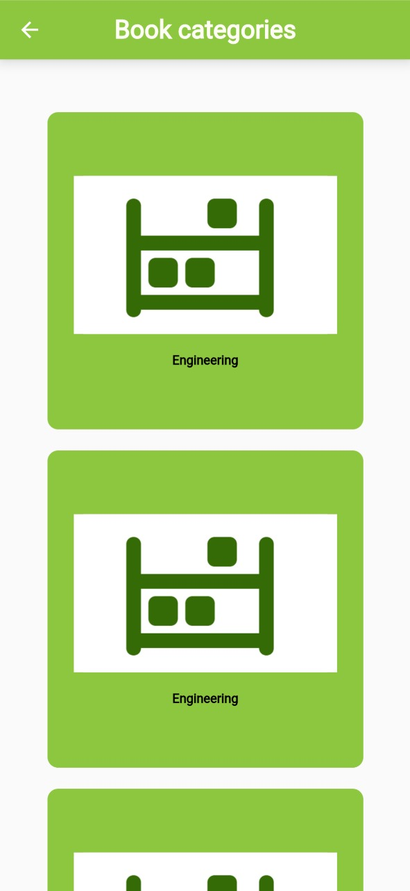

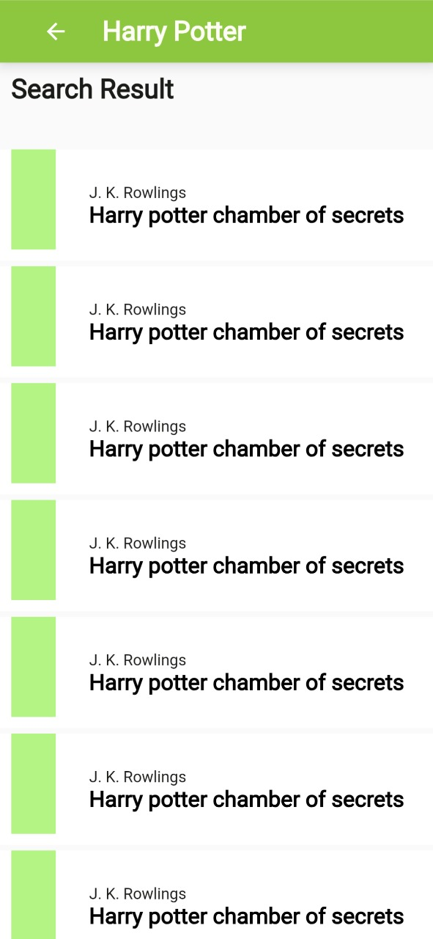

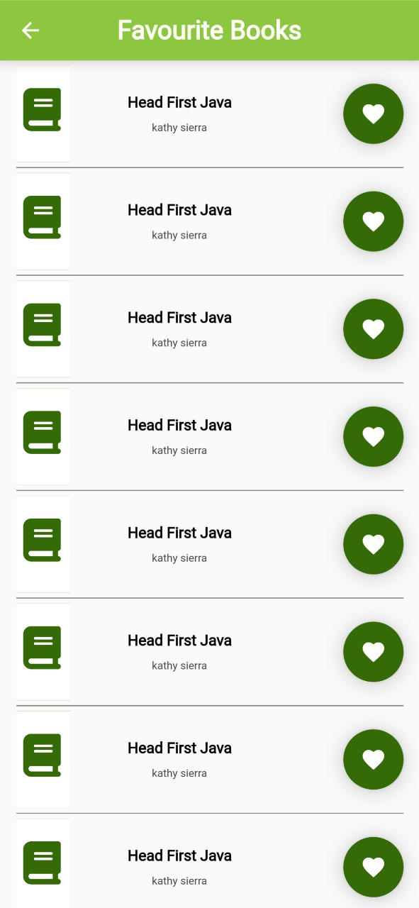

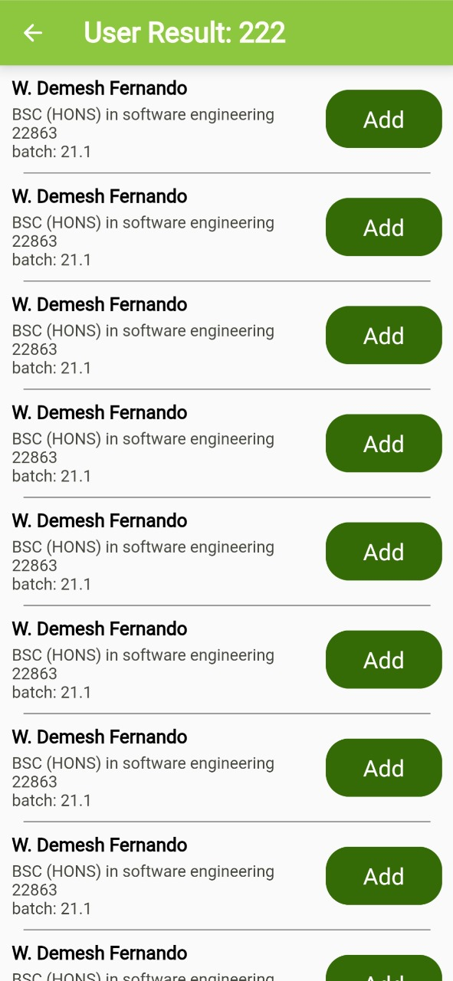

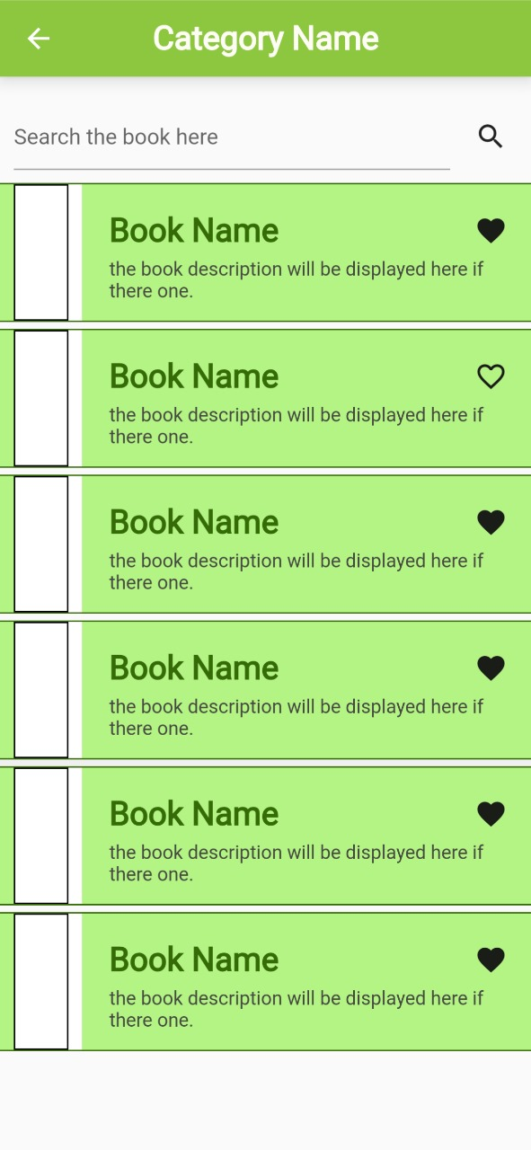

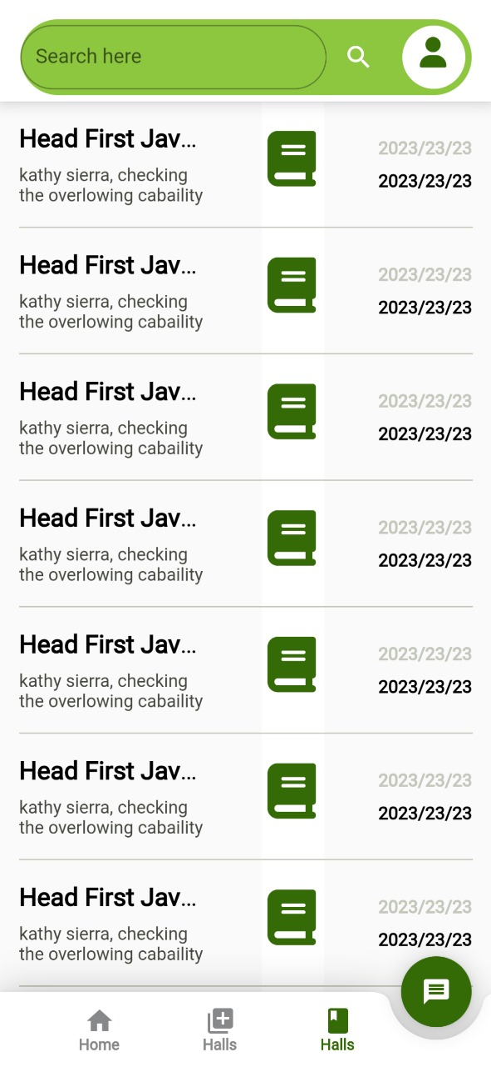

1. **Technologies Used**

**Framework:**

* Flutter - The open-source UI software development toolkit which was developed by Google known as Flutter enables the development of natively compiled desktop, online, and mobile applications from a single codebase.
* Having an impact on the project using Flutter guarantees a unified and appealing user interface on both iOS and Android devices. Because there is only one codebase, maintenance and changes can be done more quickly and easily.

**Programming Language:**

* Dart - Dart is a language designed specifically for creating desktop, server, web, and mobile apps. It serves as the main language for developing Flutter.
* Dart was a good choice due to its effective operation and compatibility with Flutter. The language had a huge impact on development speed and agility thanks to its strong support for current development workflows, asynchronous programming, and hot reloading.

**9. Integrations with Other Systems**

**Backend**

**Firebase Authentication and Firebase Core:**

* Secure and user-friendly authentication services are offered using Firebase Authentication. The dependency for Firebase services is Firebase Core.
* Firebase Authentication ensures the login and user authentication which ensures that user login and authentication within the app are secure and effective, For both consumers and developers, it makes the authentication process simpler.

**Cloud Firestore:**

* NoSQL cloud database, to store and sync data.
* Data about books, users, reservations, and other things are stored in the cloud Firestore. Users will always have access to the most recent and correct information because of its real-time sync features.

**Cloud Firestore:**

* State management library which is used to manage app-wide states.
* The provider assists in effectively managing the app's state and guaranteeing a seamless user experience. It's especially helpful for handling user identification and controlling the app's book borrowing status.

**Frontend**

**GetX:**

* Provides navigation services, dialogs, and snack bars for Flutter apps. Using this package, it is possible to navigate between different sections of the app and display the error messages and alerts.

**Hexcolor:**

* This is a utility that converts hex color codes to Flutter color objects. This utility simplifies and makes it easier for developers to integrate color into their apps.

**Dots indicator:**

* This is a package used to create dot indicators for image carousels. Enhance the UI by providing a visual representation of the carousel content.

**Flutter Spinkit:**

* This is a loading indicators collection animated by Flutter.

**Awesome Dialog:**

* This is a flutter package used to create custom dialogs. Displays enhanced and informative dialogs to users.

**Google Fonts:**

* A library which used to manage a wide range of fonts and enables the use of many visually good and enhanced fonts.

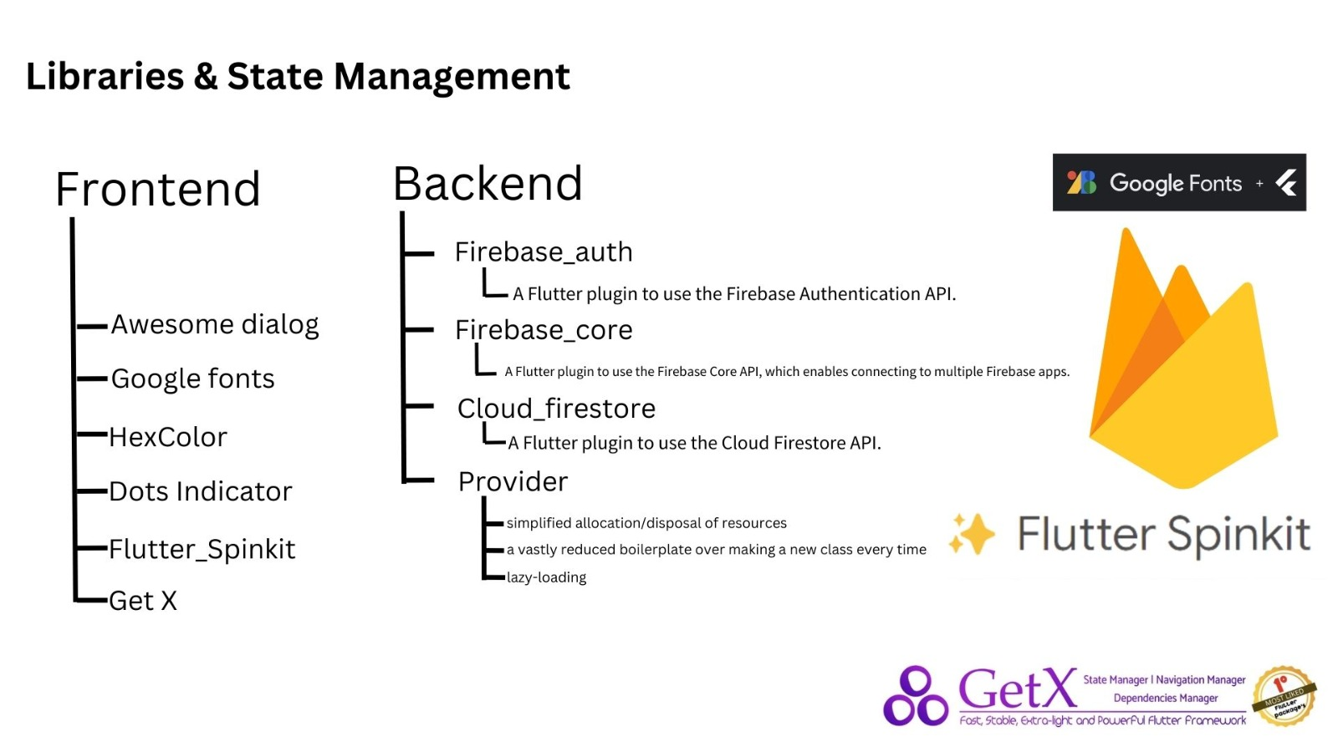

1. **High-level Architecture**

**Frontend Mobile App :**

* Backend Services - Cloud Functions, Real-time Database, and Authentication are some services that are running in the background for the app to perform to the user’s expectations.
* External Services - Firebase Cloud Messaging (FCM) is integrated to handle push notifications
* Database - Our project utilizes Firebase Realtime Database as the primary database for storing user profiles, preferences

**Interactions and Flow:**

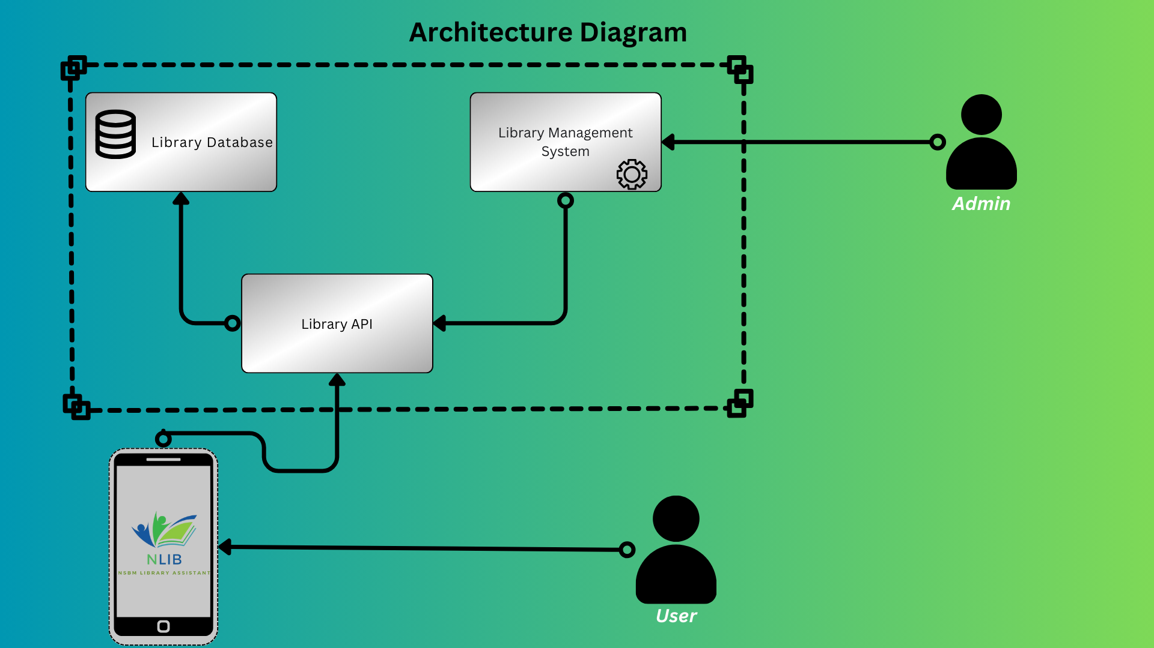

Scalability:

* Thanks to Firebase's cloud-based architecture, our project can grow smoothly to serve a larger user base.

Real-Time Interaction:

* Our app is dynamic and interactive thanks to the use of Firebase Realtime Database, which enables real-time data synchronization. This helps us achieve the goal of providing a responsive user experience for our project.

User Engagement:

* By delivering timely updates and personalized content, push notifications powered by Firebase Cloud Messaging improve user engagement. This supports our goal of keeping users informed and engaged.

Security:

* Firebase Authentication makes sure that users can access our app in a secure way, and Firebase offers strong security measures to safeguard sensitive data and user information.

Efficiency:

* Firebase's pre-built backend services shorten the development process and free up our time so we can concentrate on improving the user experience and enhancing the utility of our app.

1. **Responsibilities of Each Team Member**

**Contributions**

|  |  |  |  |
| --- | --- | --- | --- |
| Index | Name | Contribution | Percentage Contribution. |
| 22851 | H.H. Senavirathne. | Contributed to  Frontend | 25% |
| 22863 | W.D. Fernando. | Contributed to  Frontend | 25% |
| 23863 | M.M.I.R. Chandrasiri. | Contributed to  Frontend | 25% |
| 22884 | K.A.U.U.D.S. Jayasekara. | Contributed to  Test Cases | 25% |
| 22809 | D.R.I. Alahakoon. | Contributed to  Backend build | 25% |
| 22803 | H.M.Y.A Afri | Contributed to  Frontend | 25% |

|  |  |
| --- | --- |
| **Name** | **Contribution Summary** |
| **W.D Fernando.** | * **Contributed to the Fronted and UI Development and Coding.** |
| M.M.I.R Chandrasiri. | * Contributed to the  **UI Development and Coding.** and Final Document Finalized. |
| K.A.U.U.D.S Jayasekara. | * Contributed to the Test Cases, Collected data, and helped to Final Document. |
| H.H Senevirathne. | * Contributed to the UI Design and Coding, Helped to Fronted. |
| D.R.I. Alahakoon. | * Contributed to the Backed Development. |
| H.M.Y.A Afri | * Contributed to the Fronted and helps Backed. |

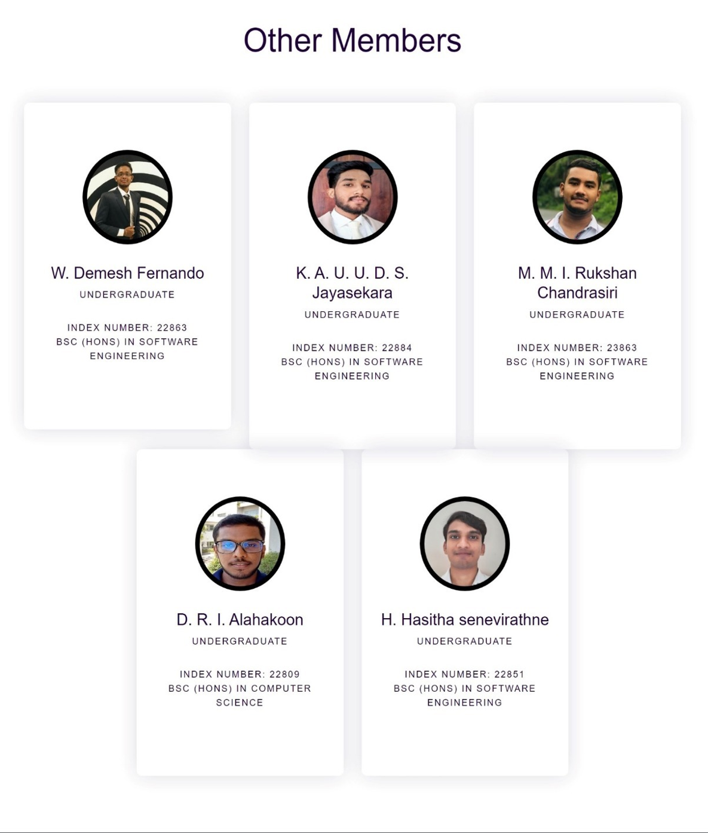

1. **Project Plan and Execution**

